Project Content:

Table of Contents

Ch_1

1)Introduction : ............................ 2) Problem Definition: ......................

3) System Objective ........................

4)WBS ......................................

5) Project Plan : ..........................

6)Project Risks :........................ 7)Safety :...............................

8) class diagram:........................

9)use case:...............................

10)

14) Security : ...........................

# 1.Introduction

It’s an engineering company that designs houses and buildings and palaces in compounds and it ‘s about constuction. It make it easy to the clients to get what they want on time rapidly .

Founded by Bayoumi Hussain in 1979. we have a long history of sustainable development and an ongoing commitment to responsible practices across six main pillars:

1_Good Work.

2_ Human, Labour rights.

3_ Environment Protection.

4_ Descipline and organiztion.

5_ Safety for the customer.

6_ Building standards and Well-being shape.

Rapidly changing consumer demands and climate change has created a greater need for fairer workplace practice, innovation and efficiencies.

we are implementing operational measures to meet these needs.

In our websites we strive inorder to make it easy and reliable to our customer , we raise awareness and reduce operating costs by installing more efficient equipment, modernizing business processes, and implementing new technologies.

Together with our partners, co-workers, and clients, we believe in a holistic approach. It will ensure that every stakeholder of the OW Group is embarking on the same journey toward a better future.

Sustainability is an integral part of our business model. It supports the UN Global Compact’s ten principles and the UN’s Sustainable Development Goals and is aligned with the Egypt Vision 2030 sustainable development strategy. As we build a better future for our customers, employees, organization, and communities, we remain focused on our mission to enrich lives.

# 2.Problem Definition

This project is about an engineering company that designs block of buildings and houses and flats , palaces in compounds and solve the problem of designing booking and the rapid response to the customers , and the customer not finding what he needs, and saving their effort and time as all products are displayed in all branches and allows the customer to easily browse the catalog and available offers and select products through the use of websites that we made to facilitate the services that they need and completing the appointment process to deal with the manager or specialized engineer or through the nearest branch after the deal is done . if there is a problem with the login there is a in accurate data or something then the clients have to sign up to build a new account. If there is a problem with initial data that our engineers produce to the clients then we have to ask what’s requirements.then if the data he entered is valid for us then we accept the data and we send them the final design andwe ask about the appropriate time to receive their residential unit. if the appropriate time isn’t good then for us then we have to reject the process.

**Convenience**: Now the whole world is moving towards ecommerce through building systems that help clients meet their needs by submitting their requests to them without the need for clients to choose what they want to build and what’s the available appointment to start the project and end the project , which means that we are very clear and stick to the time we scheduled.

**Increasing production:** Where the best-selling are followed up to increase their designs, and the least to be developed to suit the client’s needs in terms of specific shapes and spaces.

## 3.System Objective

**Revenue** : Revenue and related targets such as market penetration for a new sales.

**Productivity** : For example, software applications that speed up work or improve its quality.

**Customer Relationships** : Developing relationships with clients such as a tool that qualifies leads for a sales process.

**Processes** : Improving business processes. For example, using a cell production technique to reduce the downtime of a production line.

**Brand** : Brand objectives such as brand image and brand awareness.

**Sustainability** : Reduce impact on the environment

**Risk Management** : Identify and address business risks. For example, a tool that estimates exchange risk based on sales forecasts.

**Skills Training and tools to improve skills** : For example, training engoneers on an innovative new design.

**Quality:** Improving the quality of your products, services, processes, environments, experiences, systems, knowledge or data.

**Performance** : Improving the performance of products, services or processes. For example, improving the turnaround time for client ordered

## 4.WBS

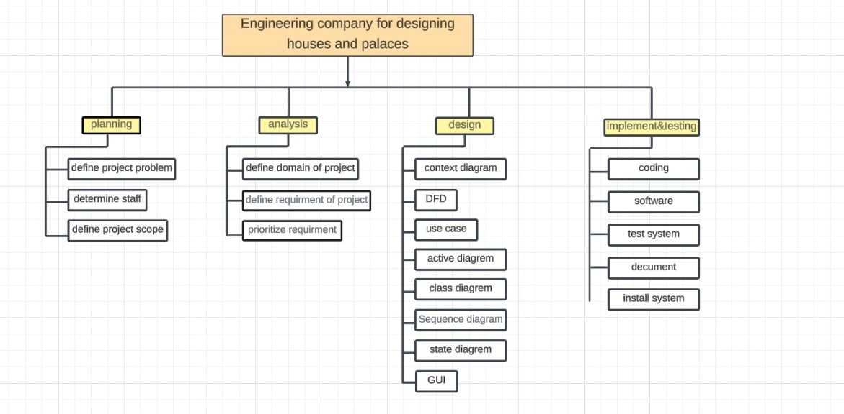

## 5.Project Plan





6. Project Risks ( Risk Source Category )

1-Inadequate Planning: Description: Poorly defined project objectives, scope, and inadequate planning may lead to confusion, scope changes, and difficulties in project execution. 2-Poor Project Leadership: Description: Ineffective leadership, lack of direction, or insufficient management oversight can result in misalignment of project goals and team disengagement. 3-Unclear Roles and Responsibilities: Description: Ambiguity in team member roles and responsibilities may lead to confusion, duplication of efforts, and delays in decision-making. 4-Communication Breakdowns: Description: Ineffective communication within the project team, with stakeholders, or between different project phases can lead to misunderstandings, errors, and delays. 5-Resource Constraints: Description: Insufficient resources, including personnel, technology, or financial resources, can lead to project delays and compromise the quality of work. 6-Scope Creep: Description: Changes in project scope without corresponding adjustments in time, budget, or resources can lead to overruns and compromise project success. 7-Technology Risks: Description: Dependence on new or unproven technologies may result in implementation challenges, compatibility issues, or the need for additional training. 8-Quality Assurance and Control Issues: Description: Inadequate quality assurance and control measures may result in design errors, rework, and compromises in the final building quality. 9-Schedule Management: Description: Inaccurate scheduling, poor time management, or failure to account for critical path activities may lead to delays in project completion. 10-Stakeholder Management: Description: Inadequate engagement with stakeholders, including clients, regulatory bodies, and end-users, may result in misunderstandings, disputes, or delays in approvals.

7.Safety

1. Establish a Safety Culture: Define Commitment: Develop and communicate a clear commitment to safety from top management to all employees. Training: Provide ongoing safety training to ensure that all personnel understand the importance of safety in the workplace. Incentives: Implement positive reinforcement for safe behavior and ensure that safety is prioritized over speed or cost. 2. Identify Hazards and Assess Risks: Hazard Identification: Conduct thorough hazard identification processes to recognize potential risks associated with the building design and construction activities. Risk Assessment: Assess the severity and likelihood of each identified hazard to prioritize actions and allocate resources effectively. 3. Implement Safety Standards and Protocols: Develop Standards: Establish safety standards and protocols based on industry best practices, regulations, and lessons learned from past incidents. Communicate Standards: Clearly communicate safety standards to all personnel and stakeholders involved in the project. 4. Safety in Design: Design for Safety: Integrate safety considerations into the design phase, identifying and mitigating potential hazards at the planning stage. Regular Reviews: Conduct regular design reviews specifically focused on safety, involving relevant stakeholders, including safety professionals. 5-Requirements Analysis: Safety Requirements: Develop safety requirements based on the identified risks. These requirements should be integrated into the overall system requirements. Traceability: Ensure that safety requirements are traceable throughout the development process. This helps in demonstrating that safety considerations are addressed at each stage. 6-Testing and Verification: Safety Testing: Conduct thorough safety testing to validate that the system meets safety requirements. This may include simulation testing, stress testing, and scenario-based testing. Independent Verification: Use independent third parties to verify the safety of the system. This provides an unbiased assessment of the system's safety measures. 7-Training and Education: User Training: Ensure that users and operators are trained on how to use the system safely. This includes understanding potential risks and knowing how to respond to safety-critical situations. Maintenance Training: Train maintenance personnel on how to identify and address potential safety issues during routine maintenance. Monitoring Systems: Implement continuous monitoring systems to detect and respond to safety issues in realtime. Incident Analysis: Investigate and analyze any safety incidents or near-misses to identify root causes and implement improvements.

8.Security

1-Threat Modeling: Identify Assets: Determine what assets your software is meant to protect (e.g., data, user information, intellectual property). Identify Threats: Understand potential threats and vulnerabilities that could compromise the security of your software. 2-Secure Coding Practices: Input Validation: Validate and sanitize all user inputs to prevent injection attacks (e.g., SQL injection, cross-site scripting). Avoid Hardcoding Secrets: Avoid hardcoding sensitive information (e.g., passwords, API keys) directly into the code. Least Privilege Principle: Implement the principle of least privilege, ensuring that users and processes have only the minimum level of access necessary to perform their functions. 3-Authentication and Authorization: Strong Authentication: Use strong and multi-factor authentication mechanisms to verify user identities. Authorization Controls: Implement robust authorization controls to ensure that users have appropriate access privileges. 4-Data Encryption: Data in Transit: Use secure communication protocols (e.g., HTTPS) to encrypt data transmitted between the client and server. Data at Rest: Encrypt sensitive data stored on servers or in databases to protect against unauthorized access. 5-Security Patching and Updates: Regular Updates: Keep all software components, libraries, and frameworks up to date with the latest security patches. Vulnerability Scanning: Regularly scan for vulnerabilities in third-party libraries and dependencies. 6-Secure Configuration: Secure Defaults: Ensure that default configurations are secure. Modify default settings and configurations to align with security best practices. Disable Unnecessary Services: Disable unnecessary services and features to reduce the attack surface.

Ch_2

System analysis refers to the process of gathering data, interpreting information, identifying issues and using the results to recommend or develop possible system improvements. During this stage, companies. may also evaluate future business needs and how improvements may answer them.

Use-case diagram describe the high-level functions and scope of our engineering company. These diagrams also identify the interactions between the system and its actors. The use cases and actors in use-case diagrams describe what the system does and how the actors use it, but not how the system operates internally.

System requirements(Functional and Non_Functional requirements)

**Functional Requirements:**

1. **User Authentication and Authorization:**
   * The system should support secure user authentication.
   * Different user roles (e.g., admin, manager, employee) with varying levels of access should be defined.
2. **Project Management:**
   * Ability to create, edit, and delete projects.
   * Assigning tasks and responsibilities to team members.
   * Tracking project progress and milestones.
3. **Resource Management:**
   * Allocation and tracking of resources (human resources, equipment, materials).
   * Schedule management for resources.
4. **Task and Workflow Management:**
   * Creation and assignment of tasks.
   * Workflow automation to streamline processes.
   * Notifications for task updates and deadlines.
5. **Document Management:**
   * Centralized repository for storing and managing project-related documents.
   * Version control for documents.
6. **Communication and Collaboration:**
   * Messaging and communication tools within the system.
   * Commenting and discussion features for projects and tasks.
   * Integration with email and other communication channels.
7. **Reporting and Analytics:**
   * Generation of standard and custom reports.
   * Analytics features for project performance evaluation.
   * Data visualization tools.
8. **Client and Stakeholder Management:**
   * Database for client information.
   * Communication tracking with clients and stakeholders.
   * Client access to relevant project information (if applicable).
9. **Budgeting and Financial Management:**
   * Budget creation and tracking.
   * Expense tracking and reporting.
   * Invoicing and payment processing.
10. **Integration with External Tools:**
    * Integration with other tools commonly used in management engineering (e.g., CAD software, project scheduling tools).

**Non-Functional Requirements:**

1. **Performance:**
   * The system should handle a specified number of concurrent users without significant performance degradation.
   * Response times for key actions (e.g., loading a project, generating a report) should meet predefined benchmarks.
2. **Reliability:**
   * The system should have a high level of availability, with minimal downtime for maintenance.
   * Data integrity and consistency should be maintained.
3. **Security:**
   * The system should implement encryption for data transmission.
   * User access controls and data access restrictions to ensure data security.
   * Regular security audits and updates to address vulnerabilities.
4. **Scalability:**
   * The system should be scalable to accommodate future growth in terms of users, projects, and data volume.
5. **Usability:**
   * The user interface should be intuitive and user-friendly.
   * Training requirements for users should be minimal.
6. **Compatibility:**
   * The system should be compatible with common web browsers and devices.
   * If applicable, compatibility with third-party software and APIs should be ensured.
7. **Maintainability:**
   * Code should be well-documented and modular.
   * Updates and patches should be easy to deploy.
8. **Legal and Compliance:**
   * The system should comply with relevant data protection and privacy laws.
   * Adequate backup and recovery mechanisms to comply with regulatory requirements.
9. **Auditability:**
   * The system should maintain logs for user activities.
   * Auditing capabilities to trace changes made to critical data.
10. **Interoperability:**
    * The system should be able to exchange data with other systems used within the organization.

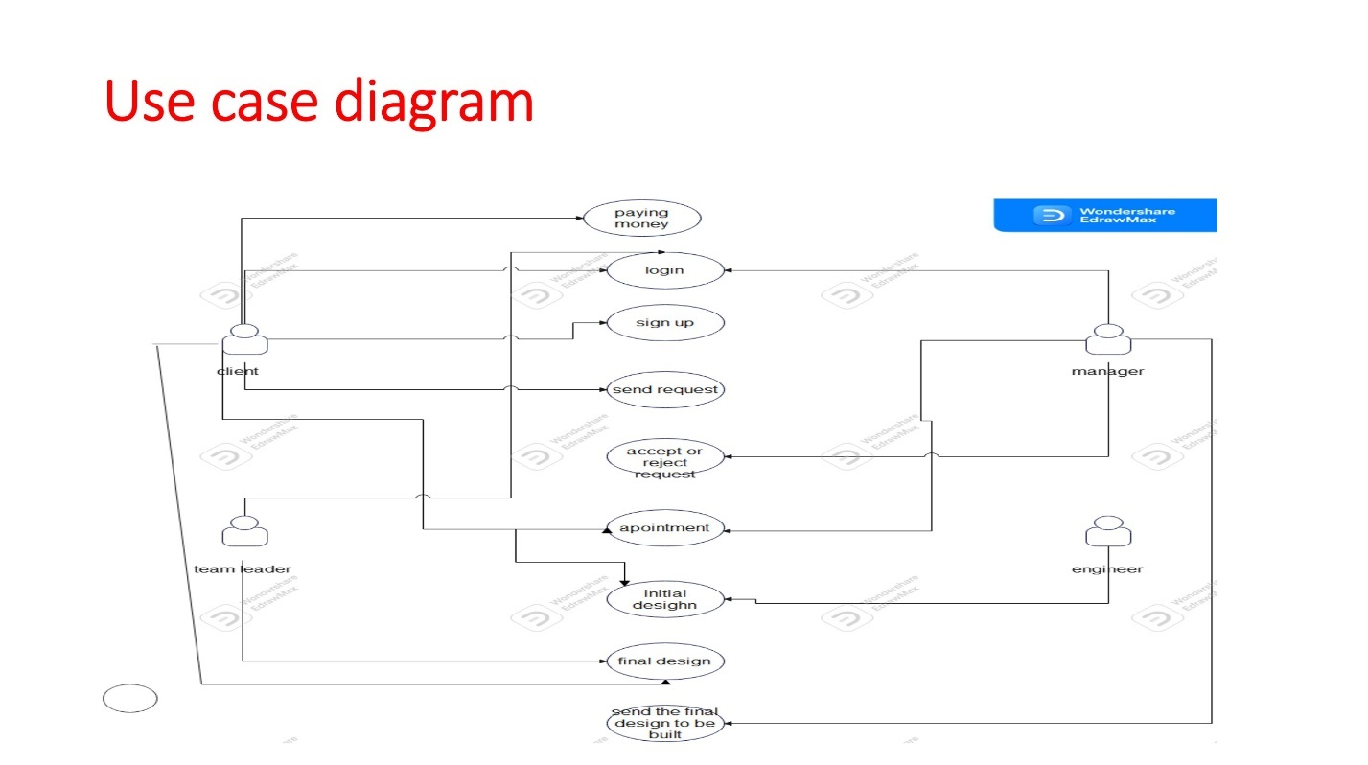

|  |  |
| --- | --- |
| **Use case** | 1 |
| **Use case name** | Login |
| **Actor** | Client  T.leader  Manager |
| **Preconditions** | A any user must be registration |
| **Postcondition** | Login successfully |
| **Normal Flow** | insert username insert the password  the system check if the username and password is correct login successfully |
| **Alternative Flows:** | 1-Register field if  he is a new user    2 -Forget password Field to help user resets his password if he forgets it |
| **Exceptions:** | The system detects that the entered username or password is incorrect.  The user is prompted to reenter the correct credentials or recover/reset their password. |

|  |  |
| --- | --- |
| **Use case** | 2 |
| **Use case name** | Sign up |
| **Actor** | Client |
| **Preconditons** | User must record data |
| **Postconditon** | Log in |
| **Normal Flow** | 1-insert username  2-insert the password  3-Confrim password  4-Login successfully |
| **Alternatve Flows:** | 1-The user field if it is recorded before  2- Send a message if your password error 3-Return The password is again |
| **Exceptons:** | The system detects that the entered username or password is incorrect.  The user is prompted to reenter the correct credentials or recover/reset their password. |

|  |  |
| --- | --- |
| **Use Case ID:** | 3 |
| **Use Case Name:** | Send request |
| **Actors:** | Client |
| **Preconditions:** | The user logged in as a client |
| **Postconditions**  **:** | The request is sent to the manager to determine to accept or reject it |
| **Normal Flow:** | The client login  System checks his data  Client send a request to book an appointment |
| **Alternative Flows:** | System error . user return to login page |
| **Exceptions:** |  |

|  |  |
| --- | --- |
| **Use Case ID:** | 4 |
| **Use Case Name:** | Accept or reject |
| **Actors:** | manager |
| **Preconditions:** | User logged in as a manager |
| **Postconditions:** | The request answer is sent to the client and set an appointment if accepted |
| **Normal Flow:** | The user logged in as a manager System checks his data manager choose to accept or reject the request |
| **Alternative Flows:** | manager rejects the request so there will be no appointment |
| **Exceptions:** |  |

|  |  |
| --- | --- |
| **Use Case ID:** | 5 |
| **Use Case Name:** | appointment |
| **Actors:** | Client, manager |
| **Preconditions:** | The client has an account |
| **Postconditions**  **:** | The request is sent to the admin to determine to accept or reject it |
| **Normal Flow:** | The client logged in  System checks his data  Client send a request to book an appointment |
| **Alternative Flows:** | System error . user return to login page |
| **Exceptions:** |  |

|  |  |
| --- | --- |
| **Use case** | 6 |
| **Use case name** | Initial design |
| **Actors** | 1_Client 2_Engineer |
| **Precondition** | Be client given details and specifications they want want. |
| **Postconditions** | 1_The engineer finishes the initial design and the client sees it. 2_The customer says what modifications he wants. |
| **Normal Flow** | 1_The designer knows the specifications and requirements.  2_The initial design is designed according to these specifications  3_The designer requests that the client view the initial design and make some modifications if he so desires |
| **Alternative Flow** | 1_If specifications and requirements are designed in an incorrect way complaining the client.  2_The company provides other designers .the designer does not exist. |
| **Exceptions** | No error |

|  |  |
| --- | --- |
| **Use case** | 7 |
| **Use case name** | Final design |
| **Actors** | 1_Client 2_Team leader |
| **Precondition** | 1_The client must have seen the initial design.  2_The designer knows what modifications he will make.  3_The designer modifieds the initial project. |
| **Postconditions** | The designer finishes the final project. |
| **Normal Flow** | 1_The designer learns the new specifications.  2_The designer modifieds the initial design.  3_The designer finished the final design. |
| **Alternative Flow** |  |
| **Exceptions** | No errors |

|  |  |
| --- | --- |
| **Use Case ID:** | 8 |
| **Use Case Name:** | Send the final design to be built |
| **Actors:** | manager |
| **Preconditions:** | The user logged in as a manager |
| **Postconditions**  **:** | The design is sent to a company to build it |
| **Normal Flow:** | The user logged in as a manager System checks his data manager choose send the design |
| **Alternative Flows:** | The design isn’t finished yet so the manager can’t send |
| **Exceptions:** |  |

|  |  |
| --- | --- |
| **Use Case ID:** | 9 |
| **Use Case Name:** | Pay money |
| **Actors:** | Client |
| **Preconditions:** | User logged in as and client  The engineers finished the design  The client is satisfied  The manager send the design to be built |
| **Postconditions**  **:** |  |
| **Normal Flow:** | The user logged in as a client  System checks his data  Client chose pay money |
| **Alternative Flows:** |  |
| **Exceptions:** | Money in the credit card isn’t enough |

Context diagram show the interactions between a system and other actors (external factors) with which the company is designed to interface. System context diagrams can be helpful in understanding the context which the system will be part of

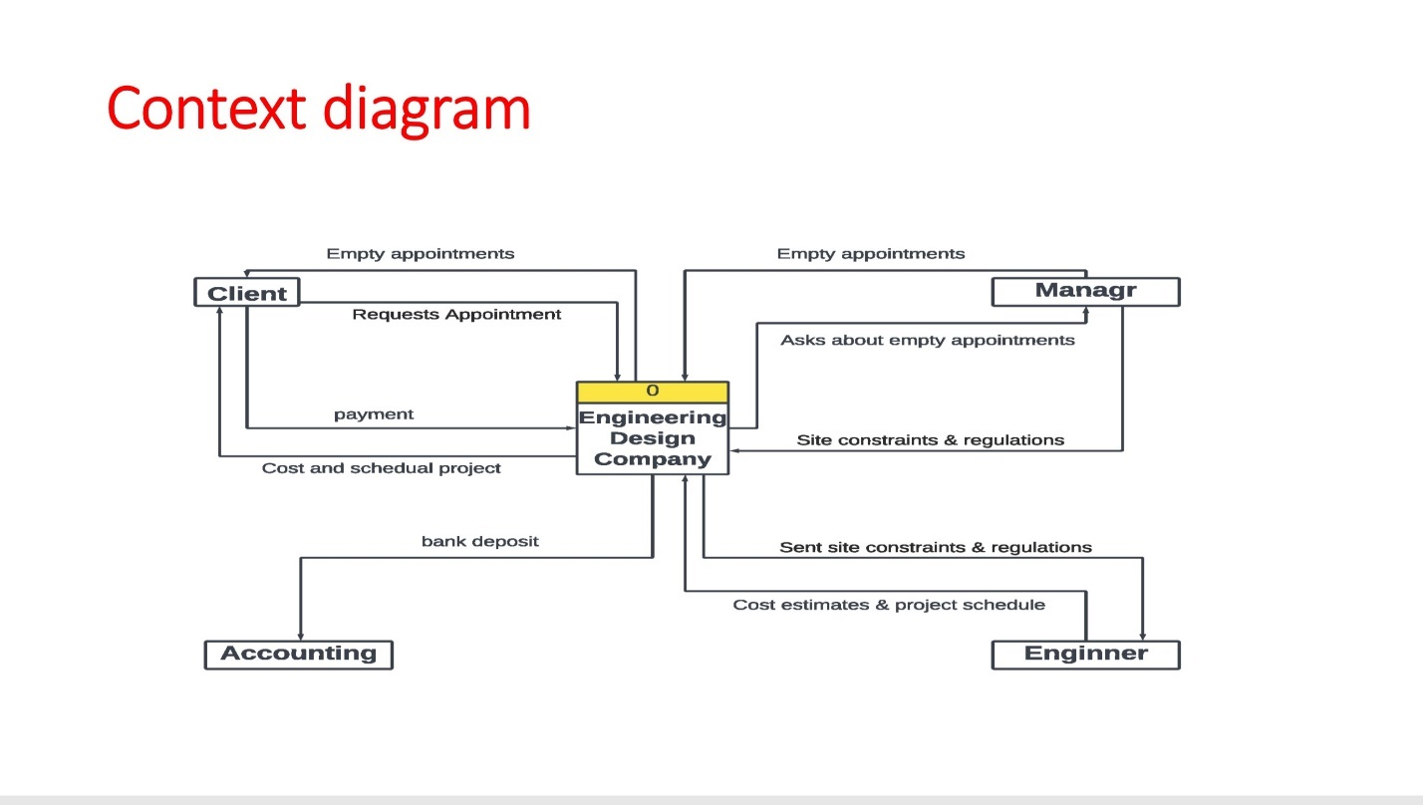

A data flow diagram (DFD) maps out the flow of information for any process or system. It uses defined symbols like rectangles, circles and arrows, plus short text labels, to show data inputs, outputs, storage points and the routes between each destination. 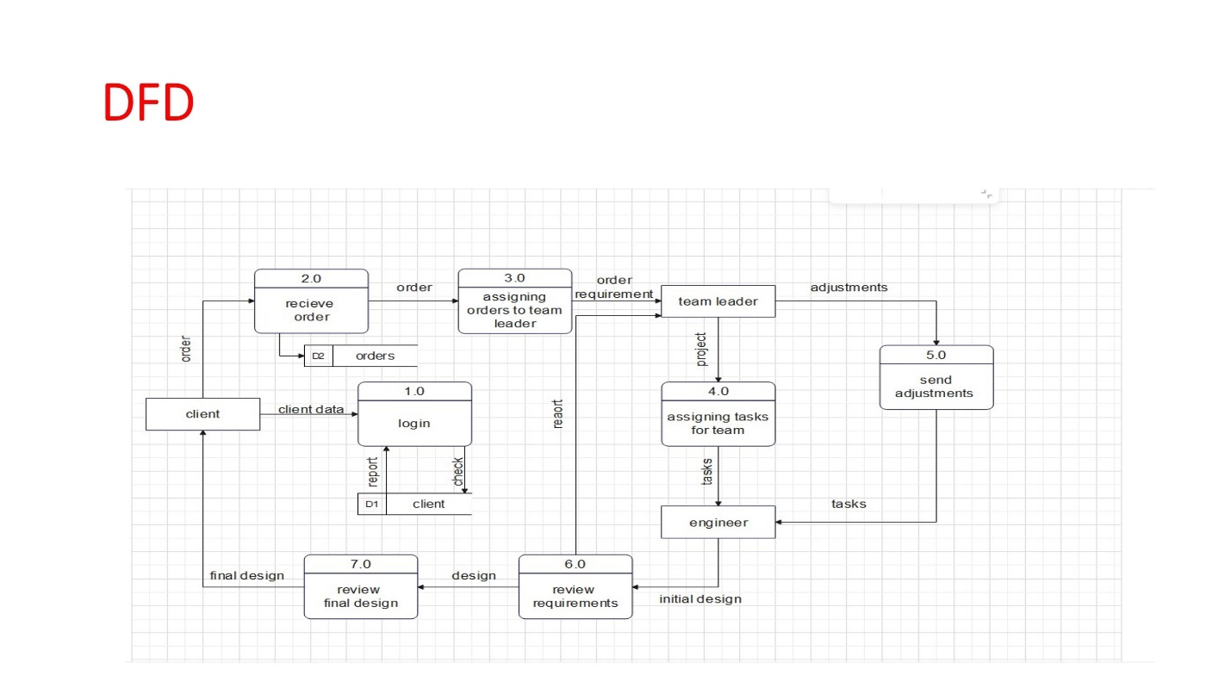

Activity diagrams show the flow of one activity to another within a system or process. Even complex systems can be visualized using activity diagrams. They are used within organizations to model customer journeys, to show the process of receiving an order through shipping to the customer, and to model sales processes.

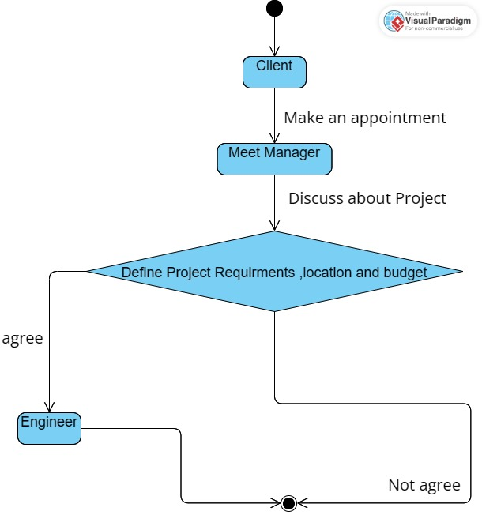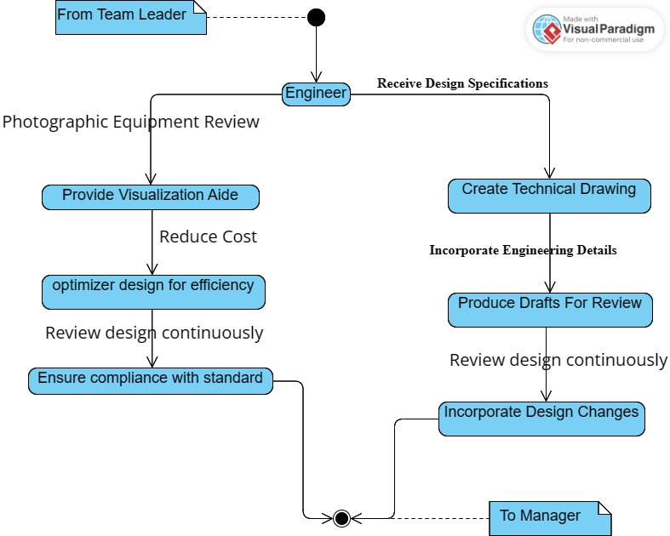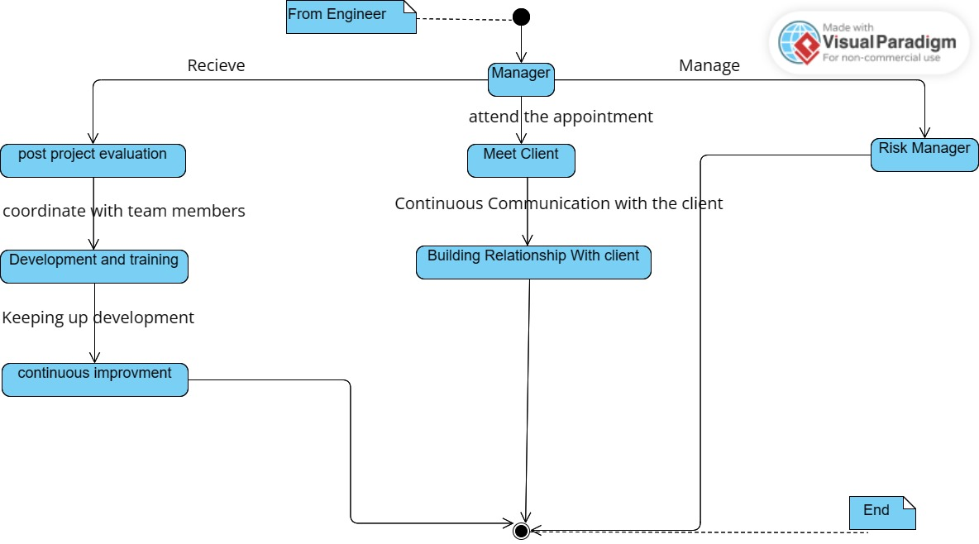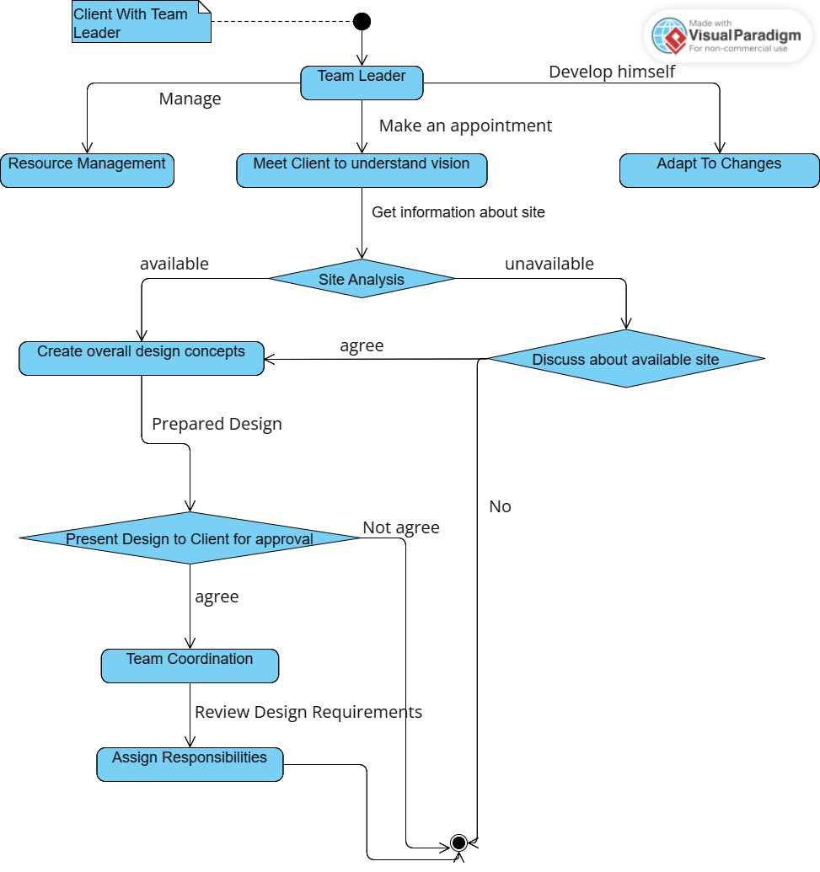

A sequence diagram shows the sequence of messages passed between objects. Sequence diagrams can also show the control structures between objects. For example, lifelines in a sequence diagram for a banking scenario can represent a customer, bank teller, or bank manager.

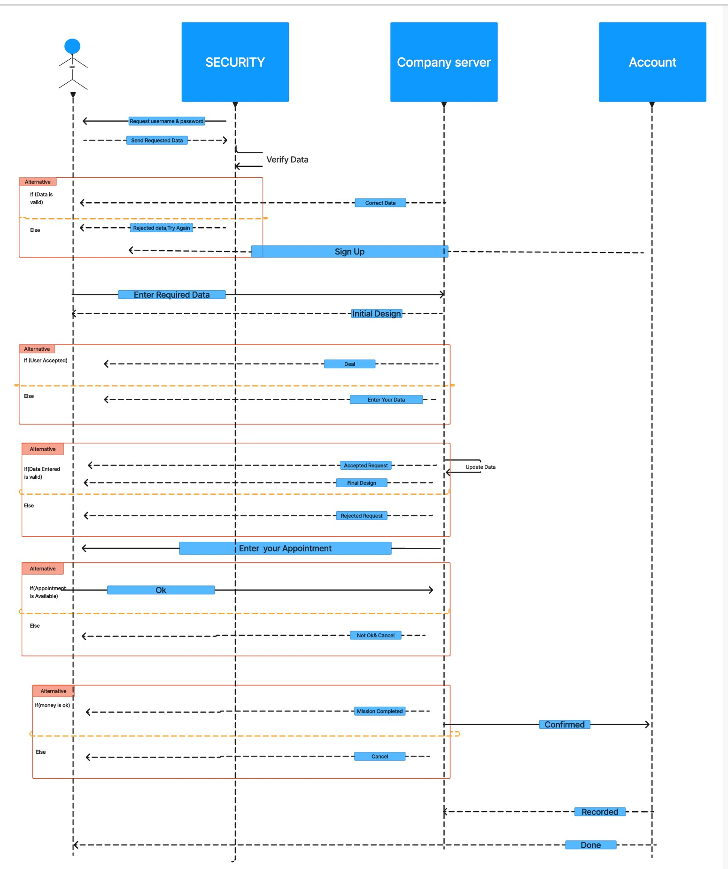

Overview. State diagrams are used to give an abstract description of the behavior of a system. This behavior is analyzed and represented by a series of events that can occur in one or more possible states.



Class diagrams are the blueprints of your system or subsystem. You can use class diagrams to model the objects that make up the system, to display the relationships between the objects, and to describe what those objects do and the services that they provide.

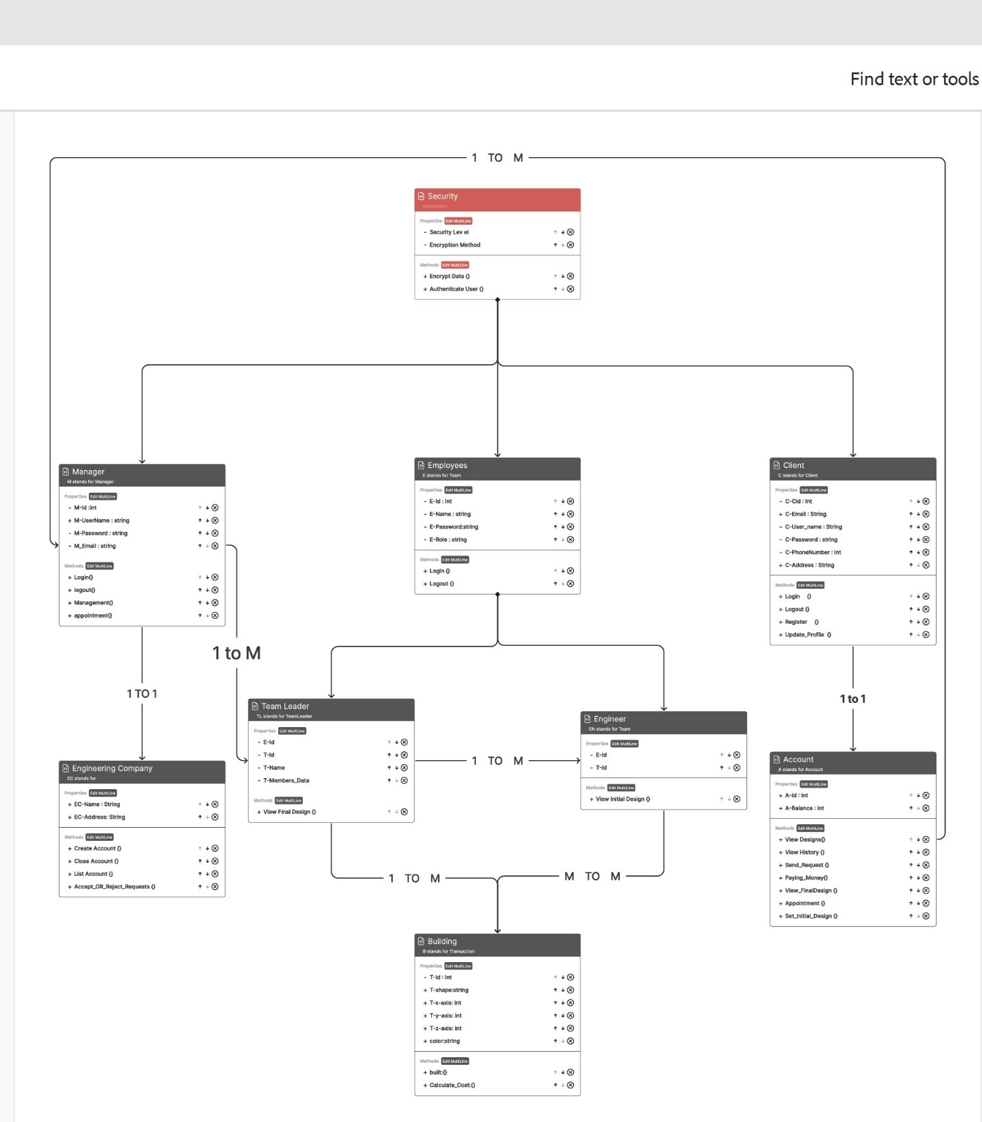

Ch_3 GUI_Design

